Workflow Control Panel Controls
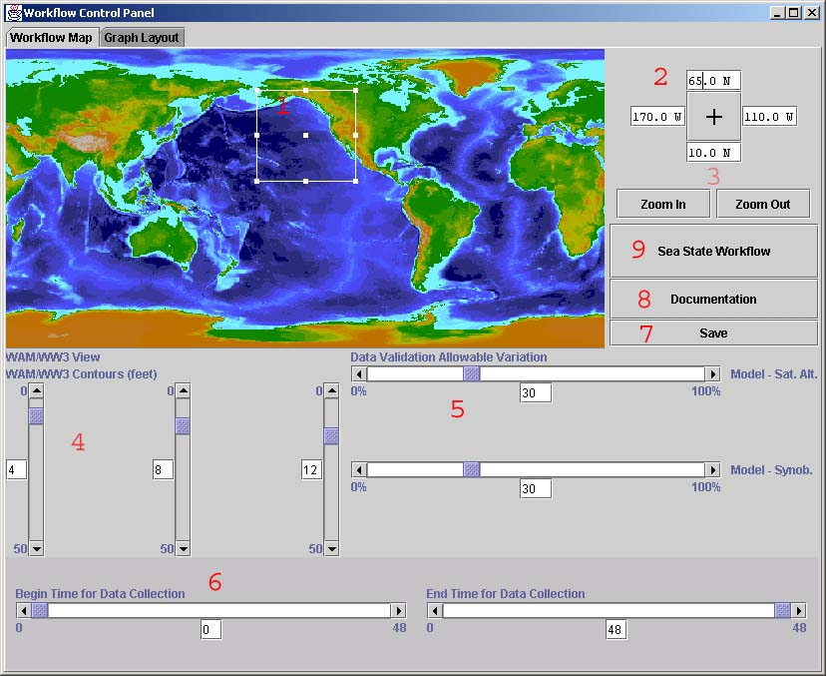

- Map box
A white rectangle on the topographic map of the earth shows the area over which data will be collected. Clicking and dragging any of the solid white boxes on the edge of the rectangle can modify the size and shape of the rectangle. The solid white box in the center allows the rectangle to be moved to a new location without changing its shape when clicked and dragged.
- Bounding box (text)
For precise control over the area in which data will be collected, a series of text boxes display the geographic extent of the map box. The text changes to reflect changes in the map box and changes to the text will be reflected in the map box. The correspondence of the text fields to the map box is simple, with the top text field representing the north box border, the bottom text field representing the south box border, the left text field representing the west box border, and the right text field representing the east box border.
- Zoom Buttons
The zoom in and out from the whole world to 180 degree by 90 degree box in three stages.
- Contour Height Sliders
Both of the model data sets displays contour the data sets on at user defined heights. To define these heights, three slider bars are provided. The contours are calculated and displayed from left to right, so contours generated from values on the left will appear under the contours generated from values on the right on the map.
- Data Validation Allowable Variation Sliders
The workflow performs some basic analysis by comparing the model data against the synoptic observations and satellite altimetry. Any data that varies from model data at that point by more than the allowable variation is color-coded white. The amount of allowable variation is settable with these two sliders.
- Collection time Sliders
This sets the time range for data to be collected in. The Begin Time slider sets the most recent time at which data will be allowed. The End Time slider sets the most distant time at which data will be allowed.
- Save State Button
If the settings are changed and the Sea State Workflow button is not pressed, the only way to save the new workflow control panel settings is by pressing the Save button.
- Documentation Button
This button brings up a copy of Internet Explorer and tries to access the online documentation (which includes this document).
- Sea State Workflow Button

