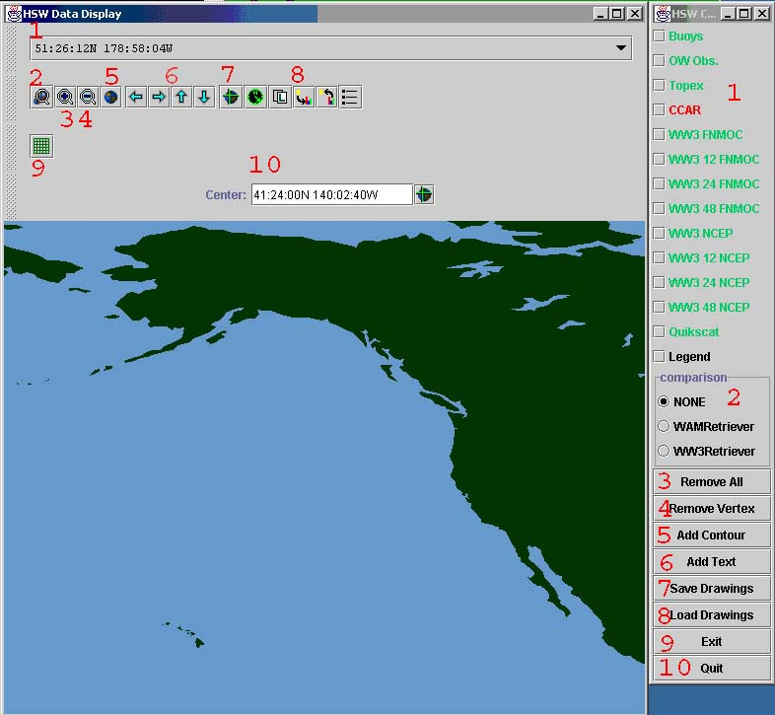

HSW Data Display Controls
- Cursor Position Text
The current geographic position of the mouse in the Data Display is listed in this box whenever the mouse is in the Data Display.
- Map Zoom to Box Button
Zooms the Data Display to the area selected by left clicking and dragging the mouse.
- Map Zoom In Button
Reduces the viewed area in the Data Display by ½.
- Map Zoom Out Button
Doubles the viewed area in the Data Display.
- Map Zoom to Whole Earth Button
Zooms the Data Display out to view as much of the earth is possible with the window aspect ratio.
- Pan Buttons
Slides the area in the Data Display in the direction indicated on the Button. The new display is shifted so that ¼ of the previously displayed area is still visible.
- Re-center Button
Re-centers the Data Display on the point selected by the left click of the mouse.
- Misc. Other Buttons
Not currently used, the functionality of these buttons has been turned off.
- Lat./Lon. Grid Button
Turns on and off the display of Latitude and Longitude grid lines along with the Arctic and Antarctic Circles, and the Tropics of Cancer and Capricorn. The grid line resolution will change to fit the current display area.
- Re-center Text
For precise placement of the center of the Data Display the text box can be edited and the cross hair icon pressed.

HSW Control Box Controls

- Displayable Data Types
The various types of data that can be displayed are listed and color coded to indicate data availability. Red means that the data set is not available, green that the set is available. Sets that are currently displayed are marked with a check in the check box.
- Comparison Selection Box
Allows for the comparison of the synoptic observations and the satellite altimetry to compared against the model data. Synoptic obs. and satellite alt. that varies from the model data more than the amount allowed by the settings in the workflow map display are highlighted in white to allow the forecaster to determine which data set is more believable.
- Remove All Button
Removes/deselects all of the data sets, leaving only user generated text and contours.
- Remove Vertex Button
The vertices that define the shape and allow for the editing of the contours can be hidden or be made to reappear by selecting this button. With the vertices hidden, the data display appears much cleaner, but the contours cannot be edited.
- Add Contour Button
After selecting this button, a contour can be generated by left clicking on the vertices of the polygon to be added until the last vertex is added by right clicking on the mouse. A dialog box will appear allowing the color, fill, boundary line thickness and vertex labels to be set.

To alter the text once it is on the data display, double left click or single right click on the text to be altered. Select the appropriate action from the pop-up menu.
- Add Text Button
After selecting this button and left or right clicking on the data display, a dialog box will appear. The dialog box contains various controls to alter the text, color, size, and font of the text displayed at the location selected on the data display.

To alter the text once it is on the data display, double left click or single right click on the text to be altered. Select the appropriate action from the pop-up menu.
- Save Drawings Button
Saves user defined text and contours to file after bringing up a dialog box to determine filename and path to save the text and contours to. Only those text and contour items that have been previously marked by selecting their individual “Add to Save List” options will be saved.
- Load Drawings Button
Brings up a dialog box that so that a file containing drawing information can be loaded and displayed.
- Exit Button
Ends the application and saves the selection of displayable data types for the next use of the application.
- Quit Button
Ends the application and does not save information about the displayable data types selected for the next use of the application.

