EVIS Architecture Workshop Meeting Notes

September 24, 2001

- Programmatic Questions:
  - Should we partner with Knowledge Web?
  - Should we partner with REDS?
  - What is the focused vision for the deliverables?
  - Should we push the data to the Regional Centers? Data Staging
- Different ships have different ways of displaying weather information. Some are simply and straightforward, but some are very complicated.
  - Use CARL VINSON’s EXCEL for Impact Spreadsheet for example
  - Why EXCEL spreadsheet? Any particular reason.
  - Should we build the EXCEL spreadsheet or build Knowledge Web tools
- Should we just model the ship forecasters’ behaviors without considering alternative procedures?
- If we shorten the development process, will our this kill the central idea of EVIS? Are our ideas mature enough to even begin building a tool? How do we fold the task 1 into the Impact Spreadsheet process?

- Research and Data Analysis Questions and Needs?
- How accurate are the forecasts (tells us the quality of the value added):
  - compare forecast wind speed against the obs.
  - Impact spreadsheet forecast against the model forecast
  - Analysis will guide us in deciding future data requirements and methodology
  - Are there other studies that quantify the accuracy of naval forecasters?
- Workflow of forecaster
  - Need workflow diagrams
  - Need time studies and time savings possible
  - Can these workflow diagrams be used by Tom Piowowar in his data flow efforts?
- Data sources used by the forecaster
- How much time does it take to produce the impact spreadsheet? Impact: quantify time savings of automation
- Why is there a heavy reliance on AFWIN products? Impact: visualization preferences.
- What are the variables/parameters needed on the impact spreadsheet?
  - First concern is to study the Air Strike problem
  - What do they want but is not easily acquired
- If user wants one click to all visualization products, what are those parameters they want to see?
- What are the Q&A Tasks forecasters do today?
- What are the cognitive processes that occur when a forecaster builds the threshold spread sheet?
- What is role of forecaster vs. the technician?
- Project Approach:
- First focus on the Strike Support problem
- Develop a prototype that can be tested and then refined
- In the near future, attempt to automate what forecasters do now that is tedious and error prone
- In the outer years, adjust the automated process according to the better understanding of the cognitive process

- Immediate Tasks:
- Complete and publish description of each experiment and data collection effort
- Create data flow diagrams for strike support
- Conduct data analysis to refine the Functional Diagram for Strike Support
- Publish the visualization and workflow needs
- Begin liaison for FY02 experiment
- Work out details for Jim’s monthly reports to Gary Toth
- Connection to REDS: NRL Monterey will coordinate with REDS to define the parameters and access method.
- Hold first quarterly review meeting in Monterey on 12 December 2001

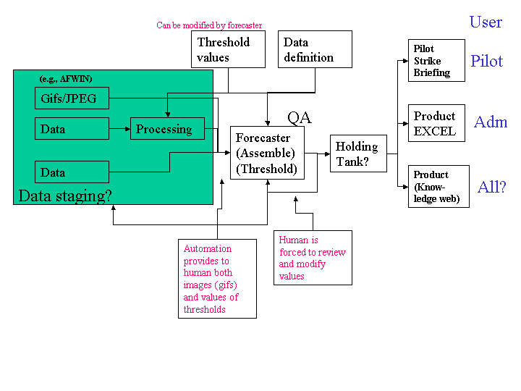
Figure 1. Architecture CONOPS Diagram

